1. In the three situations shown find the pressure at A or the pressure difference between A and B, as the case may be.

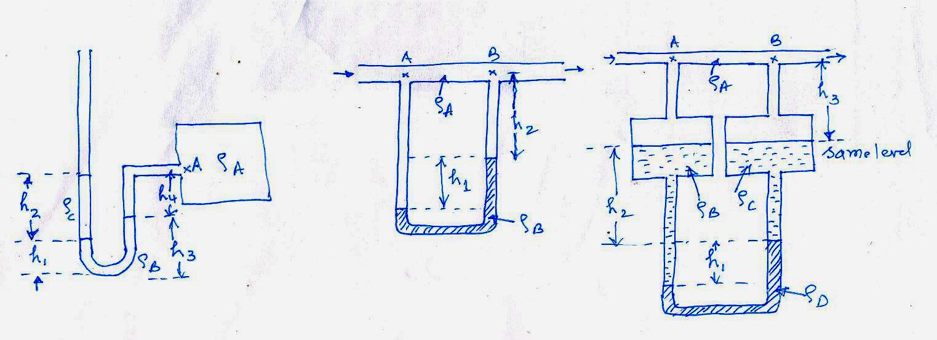

(a) (b) (c)



1. 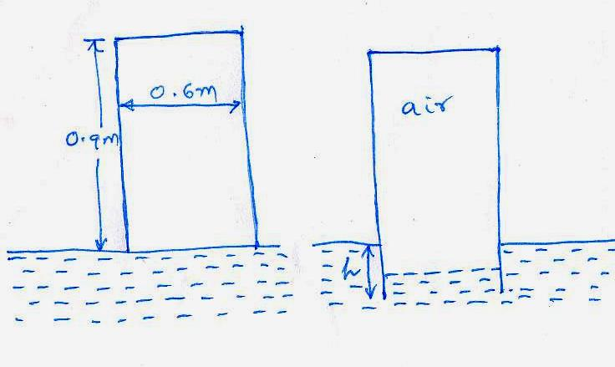 An open cylindrical tank shown in the figure weighing 100kg is allowed to progressively submerge in water as shown. To what depth h will the tank submerge when it becomes stationary? The local barometer pressure is 1.013x105 Pa. The thickness of the tank may be neglected. What additional force is required to bring the top of the tank flush with the water surface ? (WWWR)

B

A

air

air, po

pin

0.6m

H

h

h1

0.9m

The way it works: you bring the cylinder down to position A when it touches the water surface. It contains air to the full height of 0.9 m. As it lowers down to position B, the air is locked inside and cannot escape. This amount of water gets compressed as the cylinder goes down increasing the inside pressure.



1. A dam spillway gate holds back water of depth *h*. The gate is symmetrical about the pivot and weighs 400 kg/m and is hinged at A. At what minimum depth of water will the gate remain locked and prevent water from overflowing ? (Take moments about the pivot A).

Solution:

Pressure diagram :

h

F1

h/3

F1 = ρgh.h/2 ; F2 = ρgh. 1;

A

F2

0.5

Gate is symmetric: each half weighs 200kg.

Now : moment balance about A: anticlockwise:

M = − F1 . h/3 + F2 . 0.5 – 200 . 9.81 . 0.5 = 0

− ρgh3 /6 + ρgh . 0.5 – 981 = 0

* 1635 h3 + 4905 h - 981 = 0

Solving: h = - 1.8245 OR 1.6217 OR 0.2028

The negative value is non physical. And, when h = 1.6217, water level is above the top of the gate which is 1 m high and is not acceptable.

Hence the result h = 0.2028m is an acceptable equilibrium position.

Is this the correct value? The moment should be anticlockwise, when h is above this value. Evaluate for, say, h = 0.23m :

M = -1635 . 0.233 + 4905 . 0.23 - 981 = + 127 N.m. Hence this is the solution we seek.

